**Recommending a Location for a New Korean Restaurant**

Marian Kim

July 27, 2020

1. **INTRODUCTION**
   1. **Background**

New York City which is a major city in New York is one the fastest growing cities in the U.S. This rapid growth of the city has attracted many people and businesses into New York. According to U.S. Census Bureau population estimates, the New York City's population increased from 8,175,133 in April of 2010 to 8,398,748 in July of 2018. This is an increase of about 224,000 residents over the 2010 mark, or 2.7 percent (NYC, 2018). Along with new grocery stores and shopping malls, the number of restaurants has also increased. In 2019, as many as nearly 60 restaurants opened in the City of New York alone (Eater New York, 2019). In such a fast-growing city, small restaurants may find it difficult to survive in a highly competitive market. This is especially true for startup restaurants with limited funding, resource, and information about the local business of New York City.

* 1. **Business Problem**

In this case, as a data scientist, you were asked by a client to find the most appropriate location for a new restaurant. Your client is a Korean cook from South Korea who has no information about the geography of New York City, New York. Your client wants to open a small Korean restaurant in the city and expects you to help him find a hot spot for his new business. Additionally, it would be helpful to give your client a few tips based on the highest-rated Korean restaurant in NYC. Therefore, our business problems will be: "In New York, if someone is looking to open a Korean restaurant, where would you recommend that he open it?" and “What restaurant tips would you give to this person?”

**1.3 Interest**

New business entrants would be interested in accurate prediction of the most beneficial hot spot in New York for competitive advantage and business values. Investors, marketers, and customers including New York City residents and tourists may also be interested in the hot spot of NYC.

1. **DATA SELECTION**

We will need to first collect the location data of all Korean restaurants in New York. Our location data will include the Korean restaurants' name, id, postal code, latitude, longitude, rating, tips, and address. We will access data through the FourSquare API interface to explore the geography of New York, locate all venues, and filter by Korean restaurants. Then, we will use the visualization library, Folium, to visualize the results. Using this location data, we will be able to find the hot spot and recommend the most appropriate location for our client's new Korean restaurant in the city.

1. **METHODOLOGY**
   1. **Exploratory Data Analysis**

Our initial New York data scraped through FourSquare API interface has resulted a total of 305 outputs involving Borough, Neighborhood, Latitude, and Longitude. To find out where most NYC residents reside, we narrowed down our dataset to a specific Borough and Neighborhood. We have created a bar graph setting x-axis as the neighborhoods per borough and y-axis as the number of neighborhoods (Graph 1).

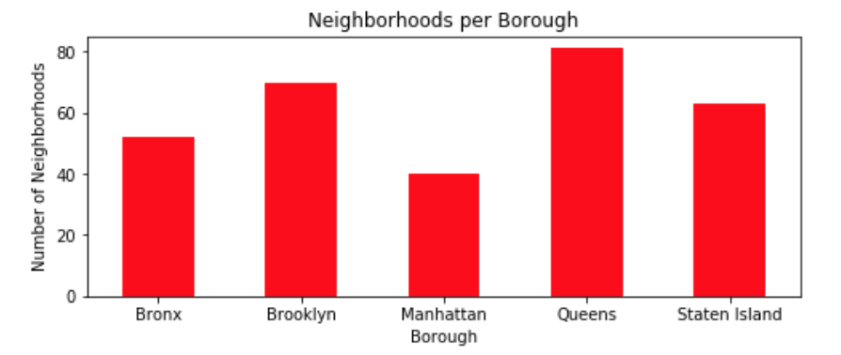

Graph 1. Bar graph of number of neighborhoods per borough

The bar graph shows that Queens has the highest number of neighborhoods per borough. On the contrary, Manhattan has the lowest number of neighborhoods per borough.

Since we are interested in the area where most Korean restaurants are located, we processed our dataset again and created a new bar graph setting x-axis as the Korean restaurants per borough and y-axis as the number of Korean restaurants (Graph 2).

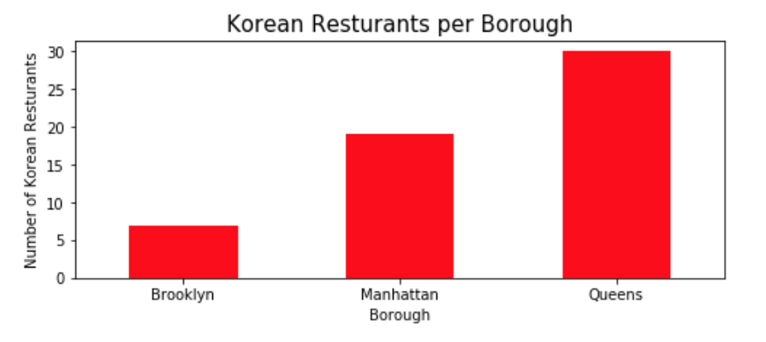

Graph 2. Bar graph of number of Korean restaurants per borough

The bar graph shows that Queens has the highest number of Korean restaurants per borough. While Manhattan has the lowest number of neighborhoods per borough, it has the second highest number of Korean restaurants per borough. To narrow down in which neighborhood of Queens has the highest number of Korean restaurants, we have created another bar graph setting x-axis as the Korean restaurants per neighborhood and y-axis as the number of Korean restaurants (Graph 3).

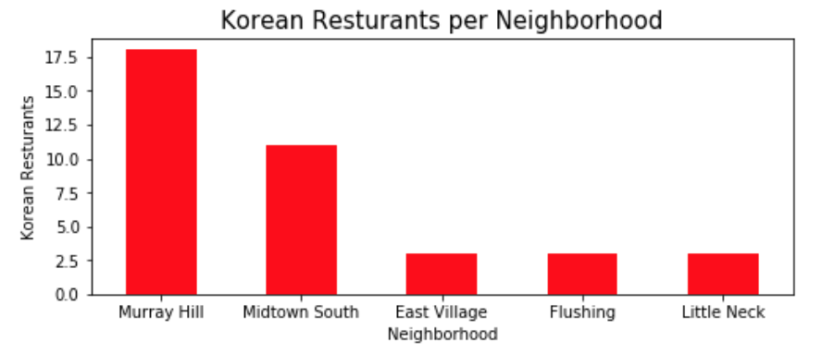

Graph 3. Bar graph of number of Korean restaurants per neighborhood

The bar graph shows that Murray Hill, Queens has the highest number of Korean restaurants per neighborhood (=18). Midtown South followed by Murray Hill has the second highest number of Korean restaurants per neighborhood.

**3.1(a) Explore a Given Venue**

With our narrowed dataset, we further examined the ratings of 18 Korean restaurants in Murray Hill, Queens, NY (Table 1).

Table 1. Rating of Korean restaurants in Murray Hill

|  |  |
| --- | --- |
| **Restaurant Name** | **Rating** |
| Sodam | 7.0 |
| Mapo BBQ | 8.5 |
| Kum Sung Chik Naengmyun | 7.9 |
| Mr. Tofu | 7.8 |
| Geo Si Gi Restaurant | 7.7 |
| SGD Tofu House & BBQ | 8.1 |
| Jongro BBQ | 7.4 |
| Bonjuk Korean Traditional Porridge Restaurant | 7.0 |
| Han Joo | 7.1 |
| Pizza Maru | 7.2 |
| 병천자매순대 (Byun Chung Soon Dae Restaurant) | 7.1 |
| Jeong Yook | 6.7 |
| Emone Korean Family Restaurant | 7.0 |
| Su Ra Chung | 6.8 |
| Hahm Ji Bach - 함지박 | **8.7** |
| 큰손 칼국수 | 6.6 |
| DAHEEN WANG MANDOO | 6.0 |
| Gugongtan | 6.0 |

This table shows that among 18 Korean restaurants in Murray Hill, Hahm Ji Bach - 함지박 has earned the highest rating (=8.7). Therefore, we have explored more about Hahm Ji Bach – 함지박and got useful tips from this restaurant. Important texts that we found as tips were “free refill”, “raspberry wine”, and “authentic Korean BBQ”.

**3.1(b) Explore the Hotspot**

Using the FourSquare API interface, we scraped data indicating popular spots in New York City. After creating groups and organizing the output based on attributes, we have identified the coordinate of the center of the hot spot (location= [40.742185, -73.992602]). To visually represent where the hot spot is, we have created a heatmap (Figure 2).

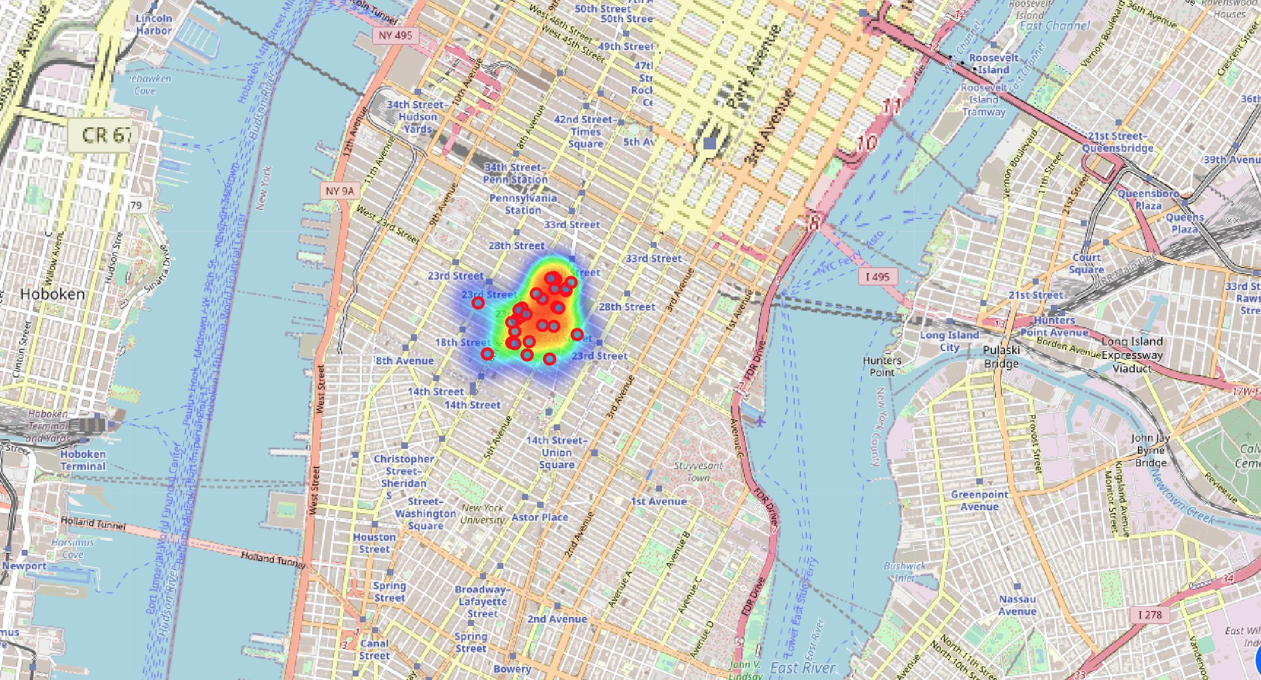

Figure 2. Heatmap of hotspot in NYC

The heatmap represents the intensity of the area of the hotspot. The red area indicates high intensity while the blue area indicates low intensity. Our recommending spot is within this red area. The small red circles represent the popular spots in the hotspot. Next, we have marked our recommending spot in blue circle on a new map (Figure 3).

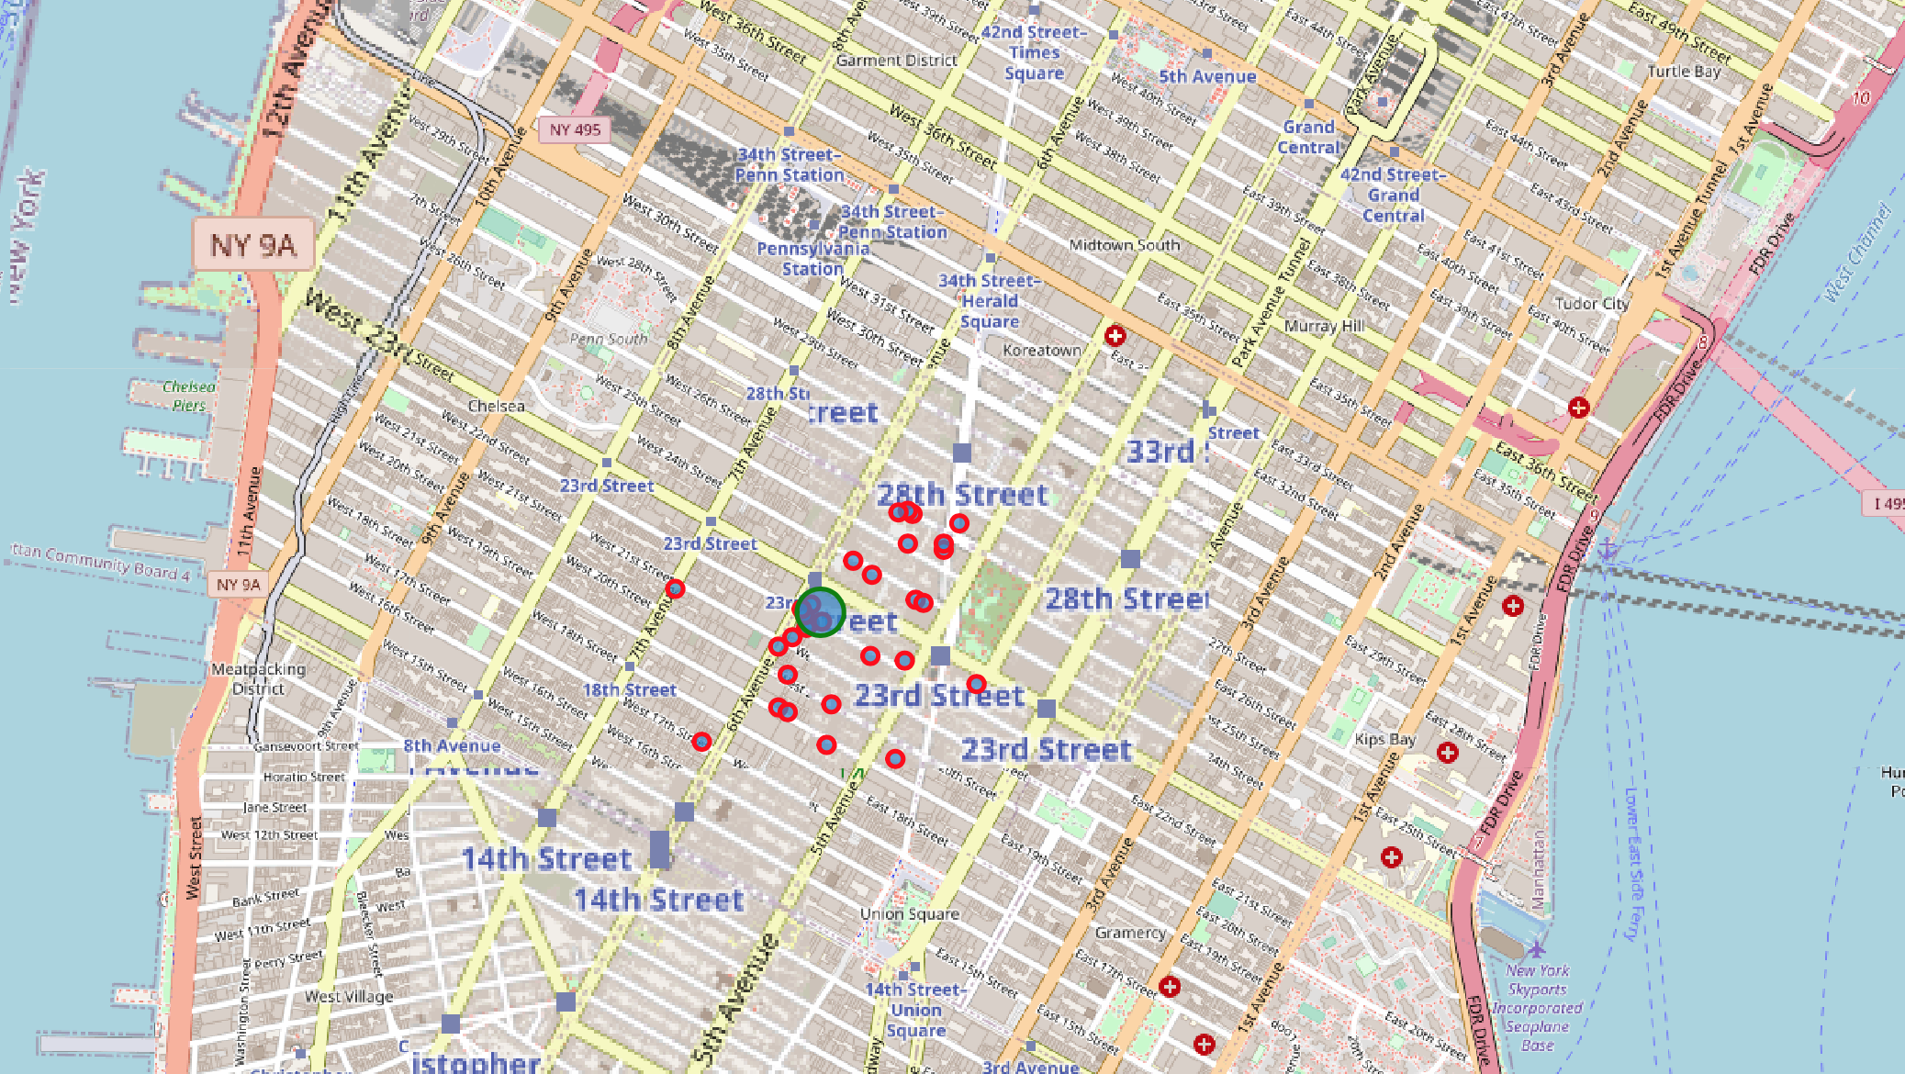

Figure 3. Recommending spot within NYC hotspot

1. **RESULTS**

Through data analysis, we have found several relevant information for our client:

* Queens has the highest number of neighborhoods per borough while Manhattan has the lowest number of neighborhoods per borough. This is a useful information for our client because it shows where most of our client’s potential customers reside. Therefore, opening a restaurant close to this location will be beneficial for our client.
* Murray Hill, Queens, NY has the highest number of Korean restaurants per neighborhood. This is a useful information for our client because this area is the most competitive area for a new Korean restaurant. Therefore, although there may be a large number of customers, our client should carefully consider about the competitiveness among Korean restaurants in Murray Hill.

Applying our findings, we can answer our business problems:

* **"In New York, if someone is looking to open a Korean restaurant, where would you recommend that he open it?"** I would recommend opening a new restaurant around the center of the hot spot as marked in our map (Figure 3.) This is an appropriate location because our map shows that our target location is near Koreatown where many Korean immigrants live. Also, in the right side of our target location, there is Madison Square Park where many tourists and NY residents come to visit.
* **“What restaurant tips would you give to this person?”** Important texts that we found as tips were “free refill”, “raspberry wine”, and “authentic Korean BBQ”. Referring to these tips, we recommend our client to consider offering free refill side dishes, providing good raspberry wine, and focusing on the authenticity of Korean foods.

1. **DISCUSSION**
   1. **Limitation**

A limitation of this study is that our data was only scraped from the FourSquare API interface. Derived from a relatively limited interface, our data may have eliminated potential variance from new or unusual hotspot settings. Therefore, our data can be skewed to a certain direction, overlooking other possible hot spots in NYC. Also, because we have used a personal developer account, we accessed only 2 of the restaurant's tips, instead of all 15 tips. Therefore, the restaurant tips that we provided to our client may have lacked diversity and depth.

**5.2 Recommendation**

Our client should take into account the competition among existing restaurants before opening his new business in our recommending spot. In addition, we suggest our client to research and consider about the financial costs and benefits of opening a new restaurant in one of the most expensive areas in NYC. Although it would attract many customers, it can be costly to pay for the rent. Finally, we recommend our client to gather more restaurant tips from other high-rated Korean restaurants to enhance the chance of success.

**5.3 Additional Research**

The results of this exploratory study suggest further research on other location data scraped from other databases besides the FourSquare. Also, opening a restaurant near countryside can be more appropriate than opening it within the hotspot depending on our client’s funding, target customer, and other preferences. This suggests the need to further research on appropriate methods that could recommend locations based on our client’s financial condition and available resources.

1. **CONCLUSION**

The rapid growth of the city has attracted many people and businesses into New York City. Along with new grocery stores and shopping malls, the number of restaurants has also increased. In such a fast-growing city, small restaurants may find it difficult to survive in a highly competitive market. This is especially true for startup restaurants with limited funding, resource, and information about the local business of New York City. Therefore, accurately predicting the most beneficial hotspot in NYC can improve the business entrants’ chance of survival and success in the city. Based on our data analysis, we recommend our client to open his new Korean restaurant around the center of the hot spot because our map shows that our target location is near Koreatown and Madison Square Park where many tourists and NY residents come to visit. Also, we recommend our client to consider offering free refill side dishes, providing good raspberry wine, and focusing on the authenticity of Korean foods for his business success. Although opening a restaurant in the hotspot of NYC seems beneficial, we suggest our client to consider about the competition, financial costs, and other possible options before starting his new business.

**REFERENCES**

Eater New York (2019). The Top NYC Restaurant Newcomers of 2019. Eater New York.

Retrieved from https://ny.eater.com/

NYC (2018). Current Estimate of New York City’s Population for July 2018. NYC.

Retrieved from https://www1.nyc.gov/